# – Implementation

## Introduction

The game flow analysis deserves particular attention for serious games (ABT, 1987), which are games used for purposes other than entertainment while still providing pleasure. Serious games have been used for aiding students to learn and understand concepts taught in classrooms (BAKER; NAVARRO; VAN DER HOEK, 2003; KOHWALTER; CLUA; MURTA, 2011; NAVARRO; VAN DER HOEK, 2004) due to their characteristic of stimulating curiosity and providing motivation for learning (PRENSKY, 2001). Understanding the educational results obtained in a serious game is important to assimilate the knowledge and concepts passed in the game. In addition, examining the game flow allows for the identification of good and bad attitudes made by the player or by game developers. This knowledge can be used in future game sessions to avoid making the same mistakes or even to adjust gameplay features.

In this chapter, the *provenance in games* conceptual framework is instantiated in the *Software Development Manager* (SDM) game (KOHWALTER; CLUA; MURTA, 2011) as a proof of concept. The SDM game focuses on introducing Software Engineering concepts and skills to undergraduate students. The version of SDM presented in this chapter makes use of the conceptual framework for collecting provenance and can be viewed by using *Prov Viewer*, an integral tool from my approach. A visualization tool for the provenance graph, named *Prov Viewer*, is also described in this chapter. *Prov Viewer* was customized to be compatible with SDM. However, it can support other games with few modifications on the interface, filters, which use SDM nomenclature, and vertices, which contains information also customized for SDM.

This chapter is organized as follows: Section 5.2 briefly describes the SDM and details of how the provenance information is gathered, generating the *game flow log*. Section 5.4 provides a simple example of game session in SDM. Section 5.5 describes details about *Prov Viewer*. Lastly, Section 5.6 presents the final considerations of this chapter.

## SDM

In SDM, which was developed using the game engine Unity3D (HIGGINS, 2010), the player has a team of employees that are used to develop software according to contracts made with customers. The gameplay and game mechanics are modeled presenting possibilities to the player, which decides strategies for development and defines the roles for each staff member. As in any contract, the software has requirements that must be followed during development. From a gameplay point of view, these requirements help to balance the mechanics and rules. When the software is completed and delivered to the customer, there is a quality assessment of the software and a project completion payment accordingly to the product quality. Figure 1 presents a screenshot of SDM in action, with the bottom corner illustrating the software’s development status.

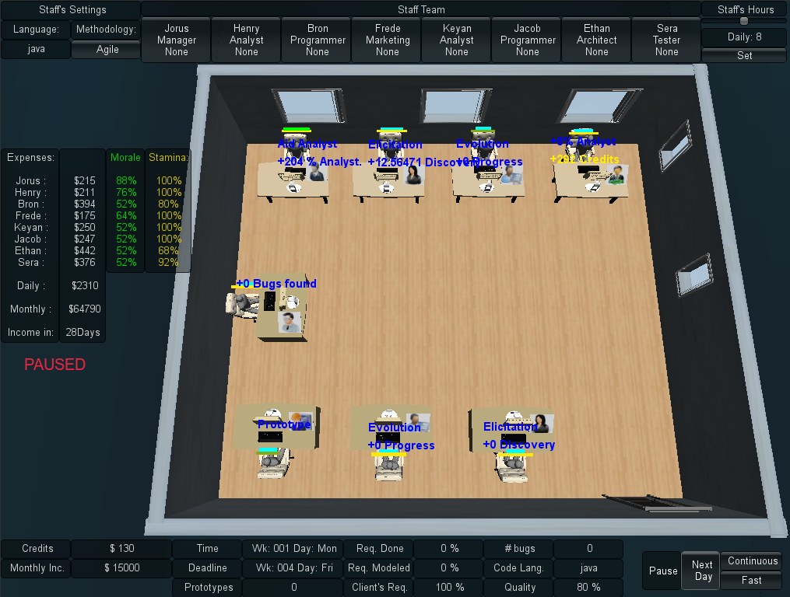

Figure : Screenshot from a game session in SDM

Since SDM focuses in people management, the main elements of the game are the employees, which represent the player’s labor force. Employees can perform different roles (analyst, architect, manager, marketing, programmer, and tester), which use the employees’ attributes to calculate their performance depending on the respective roles. Their names and roles are displayed at the top corner of Figure 1. Another element present in the game is specialization, used to define the employee working competence. With the specialization system, it is possible for employees to undergo training to learn new sets of skills. Also the concepts of working hours, morale, and stamina are used to modify the employee’s productivity. The left corner of Figure 1 illustrates the status of morale and stamina for each employee in the staff. Figure 2 shows a simplified version of SDM’s class diagram focusing on the employee, displaying his human attributes, types of specializations, the possibility of training to acquire specializations, and that the employee is affected by the other employees in the staff team. It also illustrates the project, its characteristics and requirement. The next subsections describe how the information is stored in the game and show examples of analysis of the generated provenance graph.

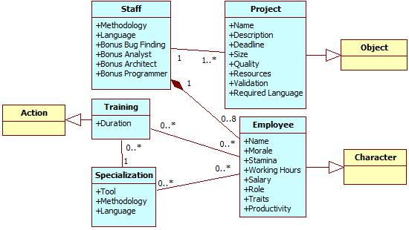

Figure : SDM simplified class diagram. Yellow classes represent generic classes from the conceptual framework (Figure X)

## Provenance Gathering

The data structure used in SDM is similar to the one explained at chapter 4. Each project contains a list of the employees involved in its development. In turn, each employee has a list of his actions executed throughout the development. If any action had an external influence during its execution, then the action also has a pointer to the action that influenced it. Throughout the game, when actions are executed or new employees are hired, information about the event is collected and stored for later usage. Actions go to their respective lists while new employees are added to the project list, creating their own list of actions. Each day passed in the game also records the state of the software development at the end of the day.

Since the information collected is used for the generation of the provenance graph, its content is mapped to the three possible types of provenance vertex (*activities*, *agents*, and *entities*). This mapping is done according to the data model explained at chapter 4. The following paragraphs describe information details that are extracted from the game and their respective roles in the provenance graph.

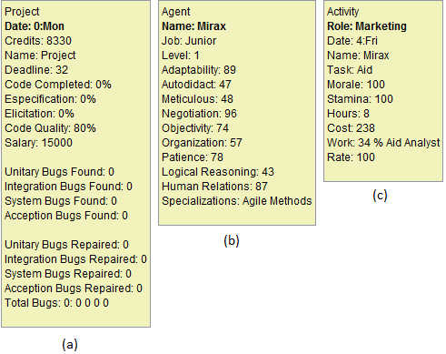

Figure 3: Information data extracted and visible at the provenance graph. The *entity* vertex representation for the project’s data (a), the employee’s *agent* vertex data (b), and the action’s *activity* vertex data (c).

Each action executed during the game is represented by an *activity* vertex. The information collected during its execution includes: who executed it, which task and role the employee was occupying, and the current morale and stamina status of the employee that executed the action. The worked hours in the day the action was generated and credits spent to execute the action are also stored. Lastly, the progress the employee made during his task. These details are illustrated in Figure 3. Besides those, if the action had any external influences, such as the use of an artifact (prototypes or test cases, for example), then SDM stores a link to the action or artifact that affected its execution.

Each employee that participated in the development of the software is mapped to an *agent* vertex in the provenance graph. The collected information includes the employee’s name, his current staff grade (junior, mid-level, or senior), his current level (and experience points), traits, and specializations. Lastly, the *entity* vertex in the provenance graph represents one of the three possible artifacts in SDM: Prototypes produced by architects and used by analysts; Test Cases produced by analysts, architects, and programmers and used by testers; and Project, which represents the instances of the software development progress recorded each day.

The daily project information collected includes the day of its instance, the project’s deadline, how much coding was produced and the code overall quality. It also stores the clients requirements identified and modeled by analysts, how many credits the player had by the end of that day, and the state of each type of bugs in the software. For prototypes and test cases, only the day they were created and their names are stored, since actions contain the information of when they were used.

Figure 3 illustrates the information collected in SDM and shown in *Prov Viewer* according to the vertex’s type. For a Project vertex (*Entity*), it is daily collected the state of development of the software, such as how much coding was done, the code quality, how many reported bugs (found) and how many were repaired. For an Agent vertex (*Agent*), it collects the character’s attributes, current level, his current placement in the company (job), and his specializations. For a Process vertex (*Activity*), it collects the character that executed the activity, his morale and stamina status, the task performed, number of hours worked, the day the activity was executed, how much it cost the player, and the outcome of the activity (work). For example, Mirax at day 4 had the “aid” task and generated a +34% bonus to all analysts that worked that day.

At the end of a gaming session, the data collected during the game session, also known as *game flow log*, is exported to an external visualization tool, the *Prov Viewer*. *Prov Viewer*, in turn, processes the data and generates the corresponding provenance graph that represents the game session. The next section describes a game scenario in SDM that is used as an example for describing the features present in *Prov Viewer*.

## Guiding Example

In this section, we exemplify a SDM game session, which explores the development process of software in the game. Over the span of five weeks, the player makes various decisions that directly affect the software development, such as hiring new employees, designating roles and tasks, and modifying the work hours of each employee. The video from this game session is also available at GEMS[1].

Starting the game, the player has at his disposal four employees: Yesha, Tornik, Mirax, and Emmy. The first thing he does is to assign roles for each employee. Yesha is assigned as the staff’s manager and has the task of aiding analysts. Tornik is assigned as an analyst, Mirax as marketing (which aids analysts and provides a cash income to the player by making deals), and, lastly, Emmy is assigned as programmer to develop the software. Then the player asks Yesha to hire tree new employees: Arden, which is placed in training, Marke, an architect, and lastly Daniel, an analyst that will work for 14 hours a day. Almost two weeks passed before Arden finished his training and was allocated to work as programmer.

Starting the third week in the game, the player begins to have financial problems. He is running out of cash. Daniel, due to the extra hours, is tired and later quits. The game continues with a few rearrangements in task. Tornik is assigned to do both elicitation and specification tasks as analyst and Arden begins to work as a programmer. Mirax is later promoted at the third week. At the forth week, Marke’s roles is changed to programmer, focusing on repairing reported bugs, and tester. Nearing the end of the week, Arden and Marke resign the staff due to lack of payments since the player was having financial problems. At the start of the next month, and after receiving cash from achieving a milestone from the contract with the client, the player hires another employee (Miera) as a programmer to replace Arden. At the same week, the player sets Mirax to negotiate with the client, asking to extend the project’s deadline by one extra week, since the deadline was ending. Because of the deadline extension, the staff manages to complete the software in time, delivering the software to the client.

The software delivered still had one reported and unfixed bug, plus another twenty five unknown bugs in the software that were not identified by the staff. Aside from the bugs, the coding quality of the software was mediocre with a rate of 75.84. This rate can vary from 10 to 120, thus 75.84 is near the average (65.0). Concerning the player’s financial status, the player started the game with 40,000 credits and at the end he had 5,969 credits and gained another 8,335 credits (out of 34,335) for delivering the software. The difference in payment is due to the number of bugs left in the software (26 bugs). Also, the player’s reputation did not increase because of the poor quality of the delivered software (number of bugs). Concerning the staff, the player kept all the starting employees, but lost three out of four hired employees. Three of the remaining employees have lost morale during the development and one is fatigued.

At the end of the session, the *game flow log* was generated by using the collected information from the game (employees, actions, and the project daily progression). The examples and illustrations present at the next section are based on the *game flow log* exported from the game session described in this section.

## Prov Viewer

The *game flow log* is used by *Prov Viewer* to generate a provenance graph corresponding to the game session. In order to do this, *Prov Viewer* processes the information and interprets it to generate the vertices and edges of the graph, as illustrated by Figure 4. As can be seen, the process is divided by three phases: Processing the *game flow log*, generating the graph, and drawing the graph.

Firstly, the *game flow log* is processed, classifying the information to their corresponding vertex types (*activity*, *entity*, or *agent*), and generating the edges that link each vertex in the graph. To simplify this step, the information extracted from the game is arranged in pairs, where each pair represents two vertices followed by the edge that links them. As such, *Prov Viewer* generates the vertices and edge every time it processes a pair of vertices. Each time *Prov Viewer* process a vertex, it searches the database to check if the vertex was already processed. If the vertex was previously processed, then *Prov Viewer* uses the processed vertex instead of creating a new entry. Otherwise, it creates the vertex. This avoids duplicates in this step, since a single vertex can appear multiple times in the *game flow log* due to the nature of how the *log* is structured: a vertex, another vertex, and the edge that links them. Thus, the vertex would appear multiple times in the log if it had multiple edges connecting it.

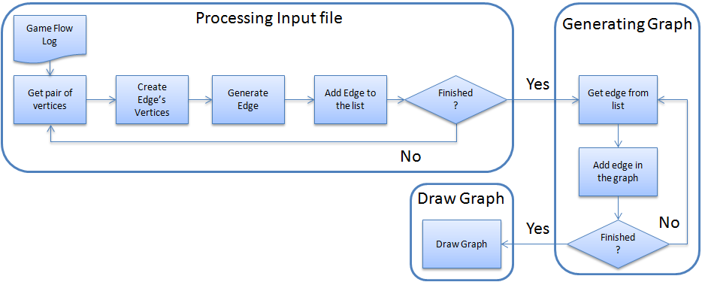

Figure 4: *Prov Viewer* processing the *game flow log* and generating the graph.

After processing both vertices, *Prov Viewer* creates the edge and stores it in a list of edges that is later used to generate the graph. In *Prov Viewer*, an edge contains pointers to the source vertex, target vertex, and edge’s information (value and type). The source and target are the previously processed vertices from the pair. This is done until the entire *game flow log* is processed and all edges are placed in a list of edges that is used to generate the graph. All information from the *game flow log* is processed in this stage, even if they don’t initially appear in the graph, due to filters.

As mentioned earlier, vertices can belong to three types: *activities*, *entities*, and *agents*. When generating the *game flow log* that contains the information extracted from the game, an additional tag is added to distinguish the vertices types. *Prov Viewer* uses this tag for generating the vertex instead of deciding which vertex type it belongs to according to the vertex characteristics, thus saving processing time. Note however that the input format can be customized, as long as it generates a list of edges, where each element in the list has the vertex source, the vertex target, and the edge information. The structure used for each line in the text file is composed of: Tag + Vertex + Vertex + Edge.

The next step is the generation of the graph. *Prov Viewer* uses the generated list of edges, creating each edge in the graph, and, consequentially, the vertices from the edges. It is done this way because *Prov Viewer* uses the JUNG framework (JOSHUA O’MADADHAIN; DANYEL FISHER; TOM NELSON, 2010), where an edge is created by adding the edge in the graph from *source* to *target* with the information *edge*. If *source* and/or *target* are not in the graph, then JUNG automatically generates the vertex. This avoids the need of creating each vertex before creating the edge in the graph, while at the same time, checking for duplicates. After creating the graph, it is drawn on the screen and displayed to the user.

### Graph Visualization and Representations

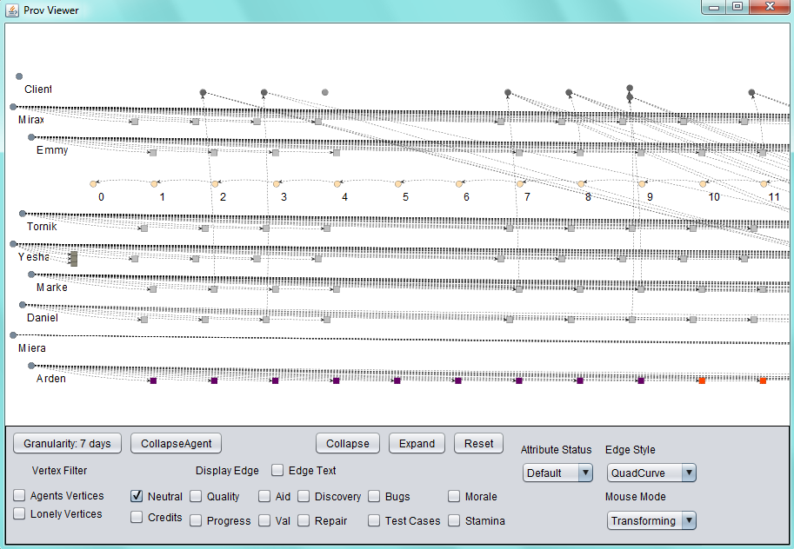

Figure 5: Prov Viewer’s GUI

After the game flow log is processed and the graph is generated, it is drawn on the screen so the user can analyze it. Figure 5 illustrates the graphical user interface (GUI) of *Prov Viewer*, using the provenance graph generated from the scenario discussed in section 5.4. The provenance graph is displayed at the center of the screen but only a part of it is visible due to the graph size. However it is possible to zoom in and out and navigate through the graph. The graph layout is set to be similar to a spread sheet, were each “line” represents the activities of each agent and each “column” represents a day in the game. The layout can be customized by creating new layouts or using existing ones available from JUNG. The filters, which are customized for SDM, are located at the lower region of the interface. Starting with the buttons, the first one is “Granularity: 7 days”. This button is only an example of grouping vertices together for the same agent. In this case, it groups vertices from the same week. This is useful for huge graphs, which allows summarizing displayed information in a weekly basis. Figure 6 illustrates the graph after turning the granularity feature on, grouping vertices in the graph for each week.

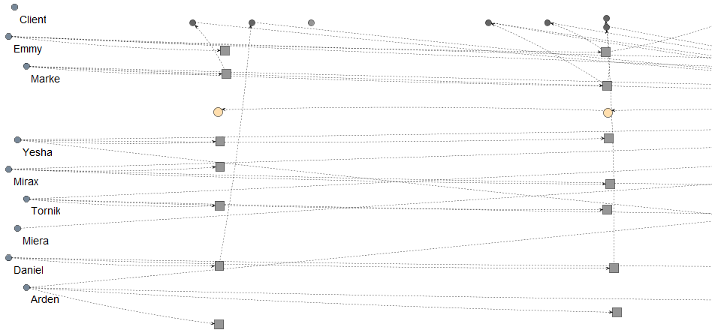

Figure : Same graph from Figure 5 with “Granularity: 7 days”

The “CollapseAgent” button collapses all the agent’s vertices into the agent itself. It can be useful to detect if an agent had any influence throughout the game, instead of looking vertex by vertex. The “Collapse” button allows the user to collapse selected vertices, while the “Extend” button remove the last collapse made to generate the selected vertex. Figure 7 illustrates an example of “CollapseAgent” and “Collapse” features while showing neutral and aid edges types. Using “CollapseAgent” on Mirax allows for easy identification that she had influenced other characters. The same figure illustrates a collapse of Daniel’s second week activities at the bottom right corner.

The “Reset” button removes all modifications made in the graph, returning it to the original state. The “Edge Style” is used to change the edge’s arrow curvature from a quad-curve to straight lines. Lastly, the “Mouse Mode” is for changing the function that the mouse will perform. There are two functions: Transform, which is used to navigate the graph, and Picking, which is used to select vertices in the graph.

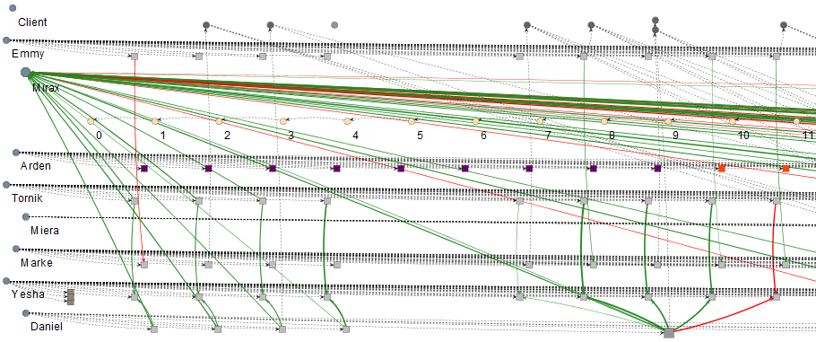

Figure : “CollapseAgent” (Mirax) and “Collapse” (Daniel’s second week)

The next items in the interface are the checkboxes used for filters. Starting with “Vertex Filters”, the “Agents Vertices” hides all agents in the graph. This is just to illustrate the possibility of hiding vertices by type. In this case, it hides *agent* type vertices. The “Lonely Vertices” hides all vertices that have no edge linking them to other vertices in the current displayed graph. This is useful to clean the graph from vertices that have no edges/influences from the selected types being displayed, reducing the number of vertices on the screen. The “Display Edge” sets the displayed graph to display only the selected types of edges. This is done changing the display status of each edge in the graph, displaying only the types selected while hiding the rest. No information is lost in this process. The information is only hidden from the user. An edge is composed of a value and a type. For example, and edge labeled as *342 validation* has a value of *342* and the *validation* type. In the case of SDM, the edge’s types can be: Credits, Quality, Progress, Aid, Val (short for Validation), Discovery, Repair, Bugs, Test Cases, Morale, and Stamina. Neutral edges are edges that represent association between vertices, while the others represent influences. Black edges represent neutral edges, which are also dotted if the edge’s value equals zero.

Note that only the “Neutral” type is selected in the displayed graph shown in Figure 5. This means that the graph is showing only neutral edges. The graph is set to always start the visualization with only the neutral type selected, pre-filtering all other edges. This is just an example of possible pre-filtering. Any type of filter can be used during the initialization of the graph. This is useful to reduce the graph granularity, hiding information from the user to avoid overwhelming him. The full graph can be seen if all edge’s types are selected, resulting in the section of the graph illustrated by Figure 8. The “Edge Text”, when selected, displays the edge label, containing its value and type. This information is also shown as a tooltip when moving the cursor to the edge. Vertices details are also available by moving the cursor over it.

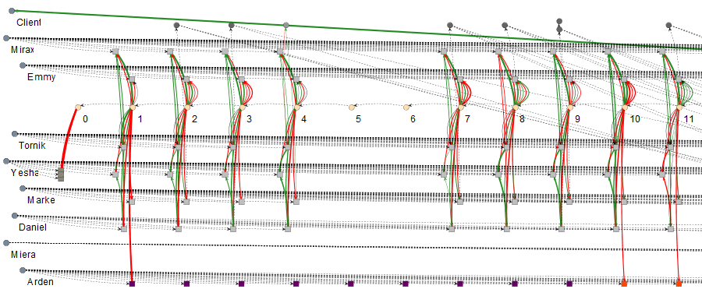

Figure 8: Same graph from but with all edges

The edge filter is important because it allows for the identification of types of influences in the graph, filtering other influences that are not relevant for the desired analysis. For example, at days 10 and 11, the employee Daniel had drastic changes in his performance, dropping from *342 validation* to *34 validation*, as shown in Figure 9. This was detected by activating the “Val” edge filter. The reason for this sudden drop can be traced to Mirax and Yesha by changing the filter to “Aid”. Yesha provided an aid of 298% in day 10 and a penalty of 248% at day 11 to Daniel due to wrong decision making. Moreover, Mirax provided 227% and 136%, respectively for days 10 and 11. By combining these factors, at day 10 Daniel receive a bonus of 525% in his task, while at day 11 he had in total a penalty of 112% for his task. Thoroughly, Daniel productivity without any bonus was 65 at day 10 and 53 at day 11, which is within his productivity margin.

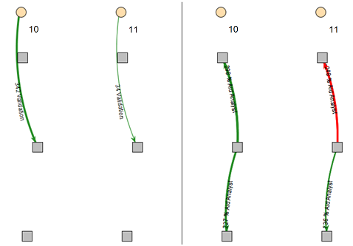

Figure 9: Analyzing Daniel's productivity. Left picture has the "Val" edge filter on. The right picture has the "Aid" edge filter on. Employees are: Yesha (upper tasks), Daniel (Middle), and Mirax (bottom).

The “Attribute Status” changes the vertex color according to their values from the selected attribute. In SDM they can be: Morale, Stamina, Hours (short for Working Hours), Weekend (highlights “Saturday” and “Sunday” vertices), Credits, and Role. The vertex color does not change if it does not have the selected attribute. The default mode colors common activities with a shade of gray and uncommon activities with different colors. Common activities in SDM are normal tasks executed by employees during their roles, while uncommon activities are activities that do not happen frequently. For example, in SDM the uncommon activities are: Idle (red color), Training (purple color), Fired (brown color), Promotion (green color), Hired (“cornsilk” color), and Negotiation (“honeydrew” color). This color difference between vertices is useful to quickly identity non-ordinary events. For example, by looking at the graph shown in Figure 10 it is possible to quickly identify that an employee trained during one week and was idle during the consecutive four days after the training was complete. In addition, Daniel was fired and Mirax was promoted in the same day. Finally, Yesha hired three new employees at the beginning of the game.

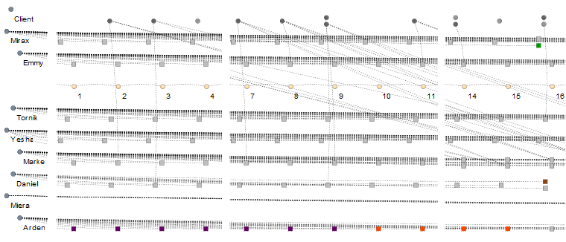

Figure 10: Same graph from but focusing on certain sections of the graph. The Attribute Status is set to default mode.

This type of visualization, based on the evaluation of attributes, is useful to quickly identify particular sections in the graph. Another example in the same scenario is to check the player’s financial status. By changing the visualization to evaluate Credits instead of the default mode, the vertices that have the player’s credits value changes their color according to its status. In SDM, the vertex that contains such information is the Project vertex. By looking at Figure 11, it is possible to see that the player ran out of credits after day 10. It is also possible to identify the source of this problem by activating the “Credits” edge filter, which is illustrated in Figure 12.

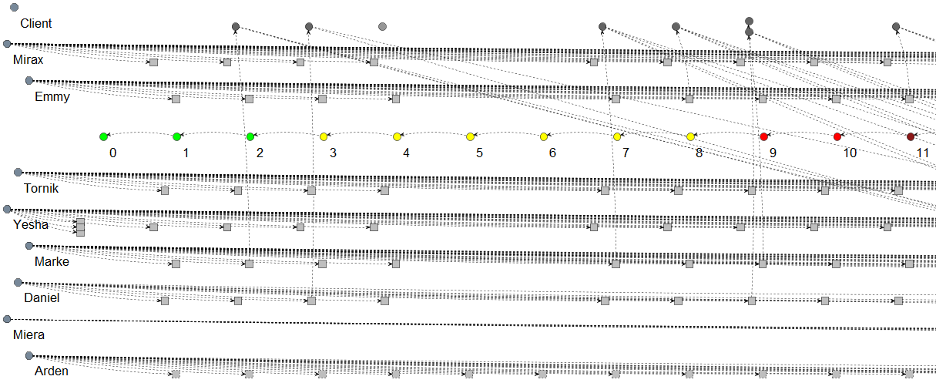

Figure 11: Same graph from Figure 4 with Attribute Status set to Credits mode

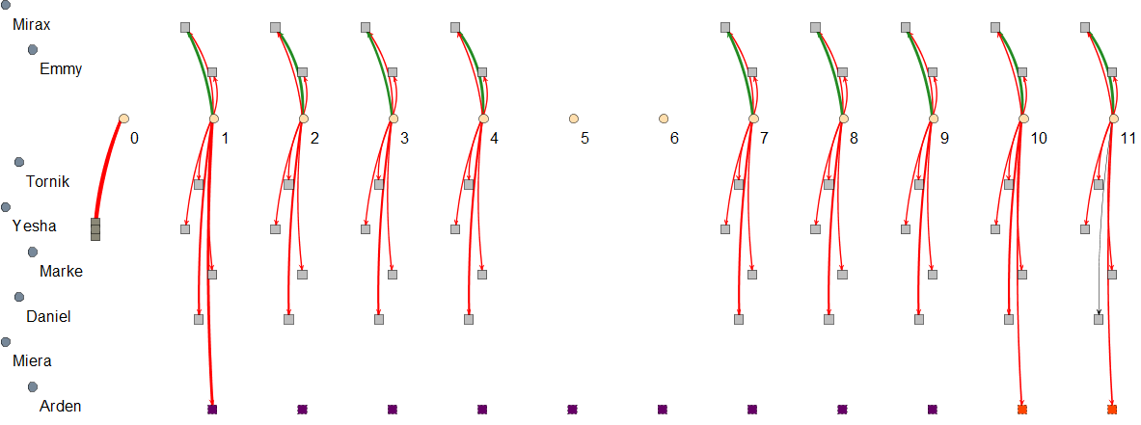

Figure 12: Same graph from Figure 4 with Attribute Status set to default mode and Credits edge filter on

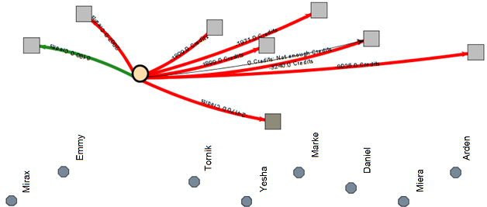

Figure 13: Same graph from Figure 4 with Attribute Status set to default mode, Credit edge filter on, and vertices collapsed (from day 0 to day 11). Figure was rotated by 90º to the left and the edge’s labels were enabled.

As can be seen in Figure 12, the player had many expenses with his employees. Hiring three new employees and training another, as illustrated by the thicker edges at days 0 and 1, was a key factor to increase this problem. It is possible to group the vertices together to better visualize the expenses, as illustrated in Figure 13, which grouped these 11 days. In total, 24,170 credits were spent with hiring, 8,036 credits with Arden, 0 credits with Miera, because she was not hired until this moment, 3,240 credits with Daniel, 1,971 credits with Marke, 1,899 credits with Yesha, 1,809 credits with Tornick, and 2,007 credits with Emmy. Mirax actually generated 6,840 credits for the player by performing her role as marketing, which provides cash, from side dealings with third parties, and aid analysts.

## Final Considerations

In this chapter it was presented the materialization of the conceptual framework presented at chapter 4, encompassing both the collection and visualization. The data gathering was done in the game SDM, where after each game session the *game flow log* was generated and exported. Then the provenance visualization was done by using *Prov Viewer*, a tool used to generate and display the provenance graph from a *game flow log*. It is important to note that in the example shown in this chapter, we focused only on the issues related to credits and validation influences. However, several other analyzes can be made by changing filters and display views, such as analyzing the reasons that lead employees to quit the staff, which week was more productive and less productive, and the reasons behinds these productivities changes.

Using the conceptual framework present at chapter 4, SDM is able to generate a *game flow log* to be used by the provenance visualization tool *Prov Viewer*, which uses graphs as notation. The contents from the *game flow log* are directly related to the information available in the graph. Features present in *Prov Viewer* were also detailed, such as visualization details and the usage of filters to change the displayed graph.

Even though this chapter shows only a section of the provenance graph (11 days), the original graph is 40 days long and contains 273 vertices and was used during the experiments described at chapter 6. However, graphs with more vertices might generate problems for the user in terms of visualization, overwhelming him with information. To deal with this, it is possible to cluster vertices and the edges together in order to simplify the graph. However, currently, these clustering must be done manually or by using the granularity feature. Nevertheless, *Prov Viewer* provides the necessary features to create complex clustering algorithms, such as clustering vertices if they satisfy specific rules or behaviors.

Even though *Prov Viewer* was customized for SDM, it can be adapted to work with other games. Most resources present in it were designed to work independently of the game context. The few features that are context dependable, like filters, have templates and are based on abstract classes for easy implementation. Lastly, we did some experiments in order to evaluate the usefulness of this provenance analysis mechanism, as described in chapter 6.

# References

ABT, Clark C. *Serious Games*. 1. ed. Abt Books: University Press of America, 1987.

BAKER, Alex; NAVARRO, Emily; VAN DER HOEK, André. Problems and Programmers: An Educational Software Engineering Card Game. *International Conference on Software Engineering (ICSE)*, p. 614–621, 2003.

HIGGINS, T. *Unity - 3D Game Engine*. Disponível em: <http://unity3d.com/>. Acesso em: 5 maio 2011.

JOSHUA O’MADADHAIN; DANYEL FISHER; TOM NELSON. *JUNG: Java Universal Network/Graph Framework*. Disponível em: <http://jung.sourceforge.net/>.

KOHWALTER, Troy; CLUA, Esteban; MURTA, Leonardo. SDM – An Educational Game for Software Engineering. *X Brazilian Symposium on Games and Digital Entertainment (SBGAMES)*, p. 222–231, 2011.

NAVARRO, Emily Oh; VAN DER HOEK, André. SimSE: an educational simulation game for teaching the Software engineering process. *ACM Special Interest Group on Computer Science Education (SIGCSE)*, v. 36, n. 3, p. 233–233, 2004.

PRENSKY, Marc. Fun, Play and Games: What Makes Games Engaging. *Digital Game-Based Learning*, p. 1–31, 2001.

1. The video can be downloaded at LINK.